Application Security Checklist in Pega

Generally after DEV, SIT, UAT we will promote our application to Production.

Best Practices are we will see whether the jar contains all the rules product files etc.. not only that we also need to see but there are server side configurations also as a lead you have to be aware of.

Pega provides a security checklist which helps us deploying the application which helps us to save time of rework of application deployment process and development process

When you login to the portal we will see at the bottom we will see application security checklist

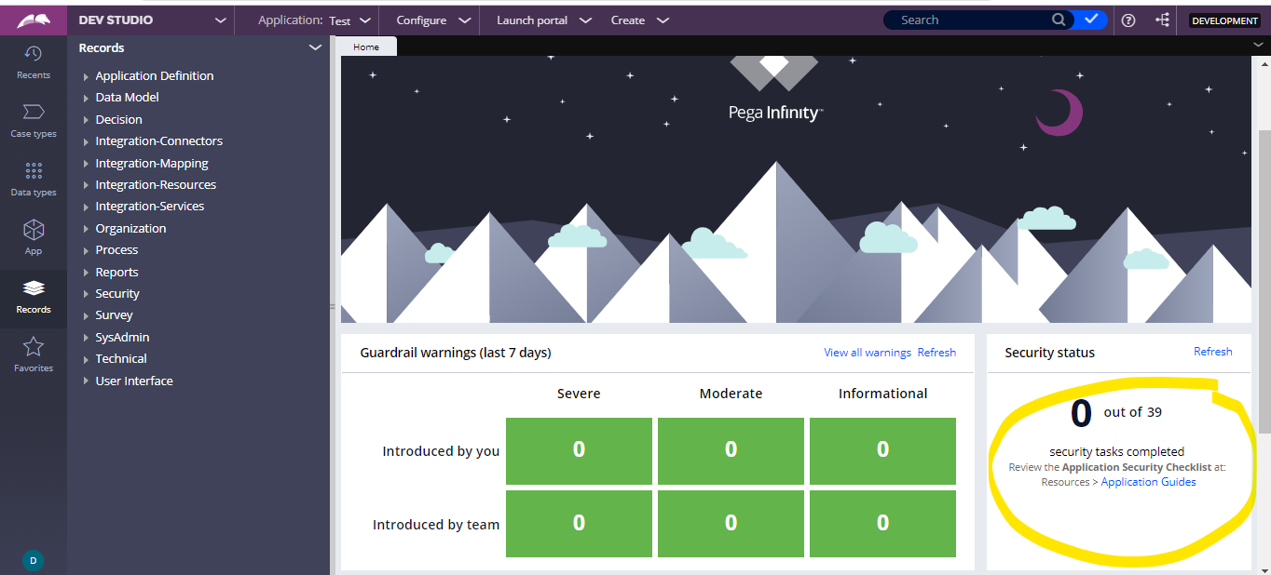

And now if we click a side navigation will open where tasks need to be completed.

We need to complete these tasks

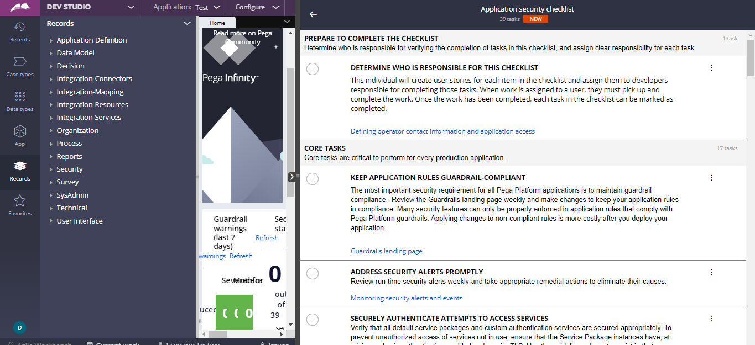

And we need to discuss this with architect as well.

We can see these application guides under

**Rule-Application-Guide**

**We need to have the Pega App Definition ruleset to use this feature**

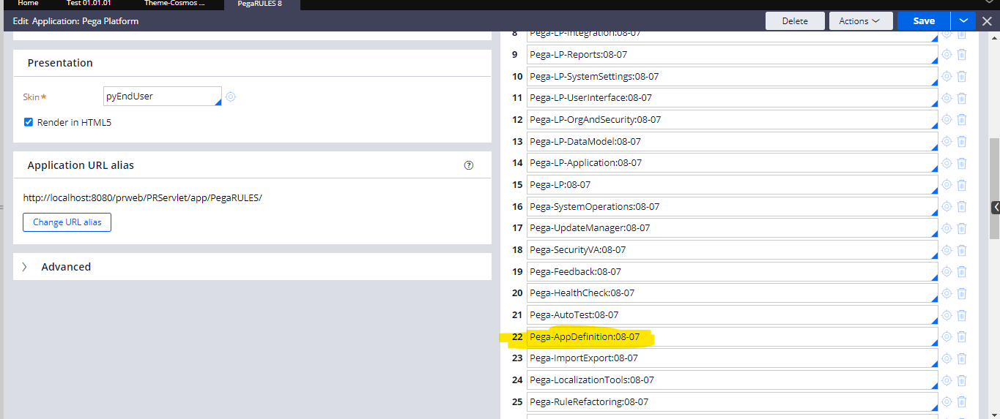

**There is also a class we need to be aware of which is Pega-Application-Guide-Work**

**In this we will have these instances as case types which will be resolved-completed which is internally a work object only.**

**And now if we complete the checks and mark it then the status will update and the checks will complete.**

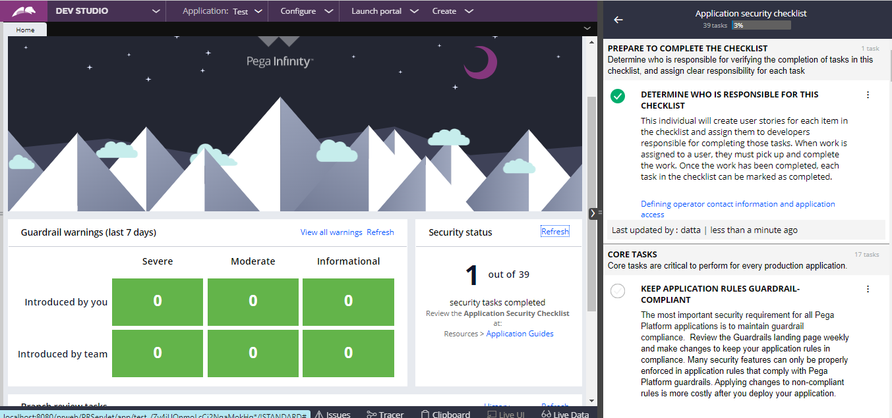

Security is critical Inadequate security can prevent your application from being deployed. Most clients require approval from an IT security team who reviews the application security before the project team is allowed to move the application to production.